**AGRIDRONE AUTOMATION OF AGRICULTURE USING IoT**

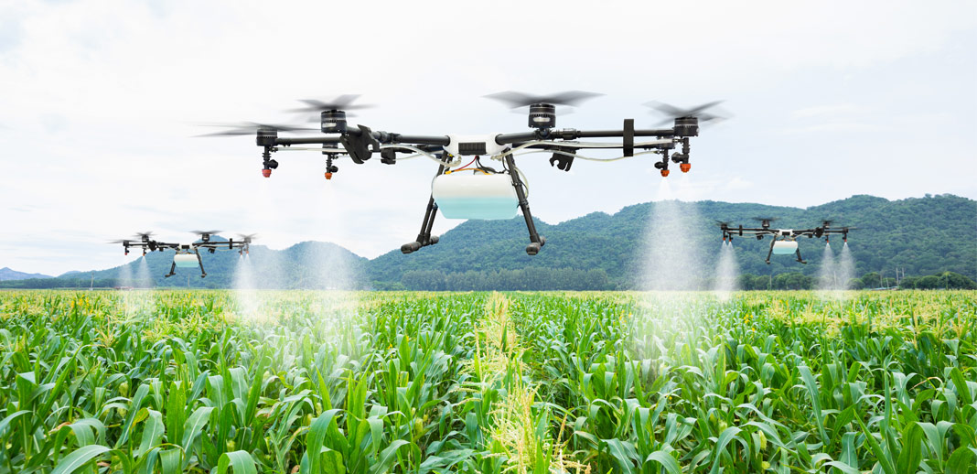

**Presented by:**

**P. Manjunath K. V. V. Brahmaiah**

**U18EC135 U18EC134**

**ECE ECE pallemanjunath52@gmail.com** [**kvvbraham@gmail.com**](mailto:kvvbraham@gmail.com)

**B. Hemanth Kumar Reddy**

**U18EC129**

**ECE**

**hemanthkumarreddy22@gmail.com**

**ABSTRACT**

Agriculture is oldest profession of mankind. Very specifically, 80 percent of indians population is engaged in agriculture related activites. No one can deny that farmers are losing their lives due to unmanageable debts increases due to failure of crops. Crop failures are due to various reasons. One of the main reasons in crop failures is due to manual based, very traitional and un-scientific agriculture practices. In this work, an intelligent system is developed to watch the development of crops and various other very time parameters of crops development.

The new system proposed here consists of a flying drone fitted with a camera eye to record images of crops in a scheduled time. The work involves developing an intelligent system by building a knowledge-base to guide agriculturists. The knowledge-base includes various crops and decisions based on crop image analysis. From captured images, the parameters that are planned for analysis by image processing are, the amount of green in leaf detection, moisture content in soil with supporting IoTs etc. The image of the plant will be acquired using the external camera eye fitted on drone which is interfaced with Raspberry Pi along with other different sensors modules through IoT. To detect green leaf, we have to install Android studio in which PlantDoctorMaster-debug.apk file is created. Now we have to copy this apk file in the handset where TH classify applications is installed.

**Keywords**: - Agriculture, Drone, Unmanned AerialVehicle(UAV), RaspberryPi, Internet of Things(IoT), Sensors.